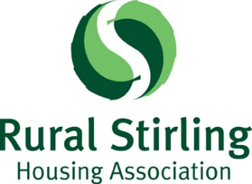 | Election of Board of Management Members  Nomination Form

Part 1

To be completed by the member making the nomination

I, ……………………………………..(name in capitals), a member of Rural Stirling Housing Association Ltd., share certificate number ……….. ,
nominate ……………………...………………(name in capitals) for election to the Board of Management of the Association.

Signature: …………………………………………………………………………….
Date: ………………………………………

Part 2
To be completed by the member who is being nominated to stand for election

I, …………………………………… (name in capitals), a member of Rural Stirling Housing Association, share certificate number ………. , accept the nomination to stand for election and declare that:

- I am willing to be elected

- I am eligible to be elected under Rule 43

- I agree to abide by the Association’s election and campaigning rules and guidelines and understand that failure to do so may result in my disqualification from being elected.

- My occupation is ………………………………………………………………….

Signature: …………………………………………………………………………….
Date: ………………………………………
This nomination form should be returned to the Association’s Secretary/Registered Office, not more than 7 days following the date of the Notice of Elections i.e. by 5 pm on 29th August 2019.

You should enclose your completed Application Form with this Nomination: the information that you provide will be included with the ballot papers issued to members entitled to vote in an election for Board Members.

