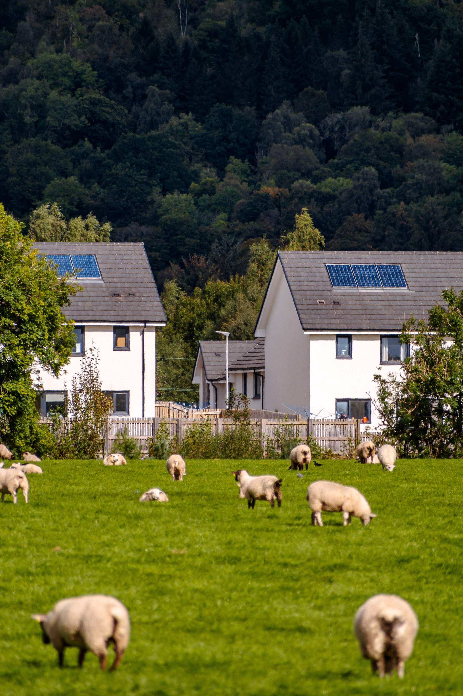

Board Recruitment Pack

Stirling Road, Doune, FK16 6AA
Tel: 01786 841101
Email: enquiries@rsha.org.uk

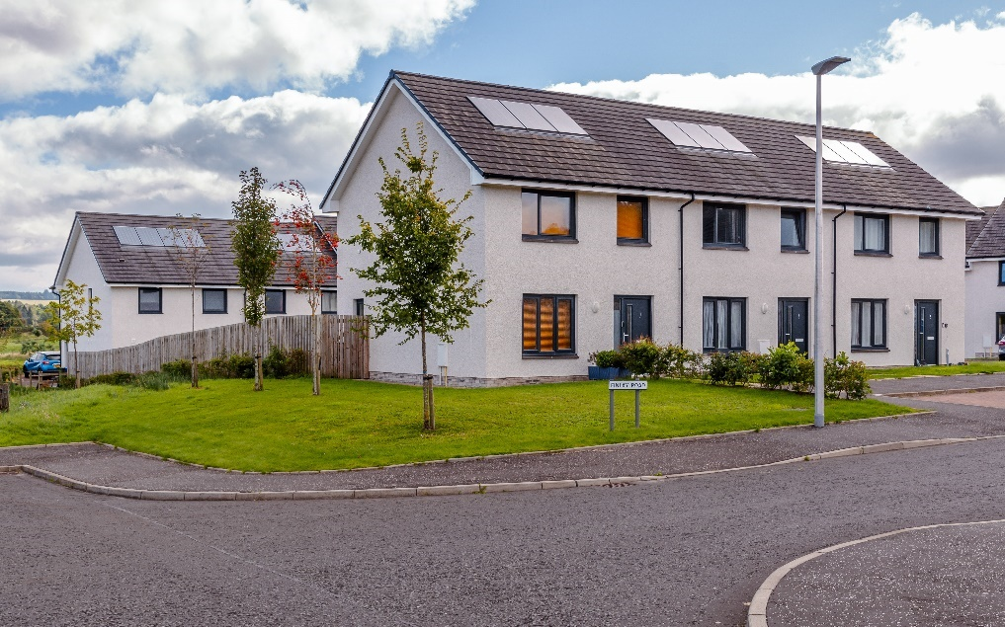

Our Story
RSHA was established in 1990 with the support of Stirling Council, Scottish Homes, and local Community Councils to develop new homes to meet an established shortfall of affordable housing. Nearly all our homes have been developed directly by us and we remain the main provider of new affordable homes within the rural Stirling area with a healthy ongoing new build development programme.
Our area of operation is defined as north and west rural Stirling Council area, stretching from Tyndrum in the north, to Strathblane and Killearn in the west and Doune in the south. The two Multi Member Wards, Trossachs & Teith and Forth & Endrick cover much of the area, with a large part falling within the boundary of Loch Lomond & the Trossachs National Park (LL&TNP).
In 2013, we established a wholly owned non-charitable trading subsidiary, Venachar Ltd., to carry out activities that deliver our objectives, but which we are unable to carry out ourselves. Together we form the Rural Stirling Group (RSG). RSHA acts as the parent in the Rural Stirling Group. Our subsidiary operates in accordance with an Independence Agreement and a Service Sharing Agreement. RSHA staff provide support to Venachar to carry out its activities.
We currently own and manage 700 homes. The majority of these are social rented, with 7 shared ownership houses also remaining in management. Six homes are leased to our subsidiary Venachar Limited, for letting on a mid-market rent basis. We also provide a factoring service to 35 homeowners within our area.
Our vision is for Strong and Attractive Rural Communities and our supporting mission is to provide affordable, high quality housing and support community aspirations. We have an ambitious new build development programme with proposals to develop more new homes in the coming years. To support us in achieving our ambitions and as part of our focus on succession planning, we are now looking for enthusiastic and committed people who share our passion for the community to join our parent company Board.

Board of Management
The Board of Management is responsible for setting strategic direction and for decision making in all key areas of the business: finance, governance, development, asset management and the provision of housing and related services.
Any member of the Association is entitled to stand for election to the Board at the Annual General Meeting, and any non-member wishing to join the Board may fill a casual vacancy or be co-opted subject to Board approval.
Board members are required to prepare for, attend and participate in Board meetings, adhere to the Code of Conduct and Association Rules, undertake training and annual review of their performance. Board members are also encouraged to join our Audit & Risk Committee, a Working Group or our Venachar Board.
If you are passionate about great housing and building strong communities, then joining our Board could be for.
We are committed to promoting equality, valuing diversity, and challenging prejudice and discrimination in all its forms. We aim to ensure that membership and participation in the governance of our organisation is open to everyone. We aim to ensure that our voluntary management Board is representative of the communities we serve, and applications are welcome from all, however we would be particularly interested in hearing from those who;
- share our values and the values of the social housing sector.
- have a genuine commitment to strengthening our local communities.
- have specific experience of being a social housing tenant.
- have finance and accounting skills and expertise, experience of IT and Digital strategy development or have professional housing experience in customer service and policy development at a senior level.
- have the confidence and ability to question and challenge effectively.
- have previous experience of being a board member or a good understanding of governance and the roles and responsibilities of being a board member.

Board members learn new skills around governance, finance, and strategic planning. Being a Board member can be a rewarding and enriching experience. This role will provide you with the opportunity for personal and professional development. You will learn about the wide range of activities undertaken within a progressive, customer focused organisation operating within the social housing sector, and you will be able to use and develop a wide range of skills, knowledge, and experience.



meeting schedule
Board members are expected to attend 8 meetings per year. There are no meetings held in January, April, July and December. Board meetings take place on a hybrid basis either in person in our Boardroom or online using Zoom. The February and November meetings are held online only using Zoom.
Our Annual General Meeting takes place in the first half of September each year where all members are invited to attend, along with invited guests and a guest speaker.
Our Audit & Risk Committee meets 3 times a year and our Venachar Board meets twice a year. We have an Ad Hoc Staffing Panel which meets as and when required.
We also currently have one Working Group set up to focus more closely on investment and development.
Annually each year a Strategy Day is held with all Board members, the CEO and Senior Management Team


Board Induction and training
Each new Board member will receive a full induction programme which includes meetings with the Chair, CEO, Senior Management Team and Corporate Services Officer.
Throughout the year, a range of training and briefing sessions are held to support and improve Board members knowledge and skills and to keep up to date with the latest legislation and regulatory requirements.

how to join our board
To apply to join our Board, please complete the attached application form and return to donna@rsha.org.uk.
Successful applicants will be invited to meet with the Chair and CEO about their interest in joining our Board and what they can bring to RSHA and the RSG.
Applicants approved to join by our Board will either fill a casual vacancy or be co-opted until the next AGM, whereby they need to stand down and confirm that they wish to stand for election to the Board. As a Board member, you must also be a member of the Association (form attached).

Further information
Should you wish further information or an informal chat please contact our CEO, Donna Birrell at donna@rsha.org.uk. We look forward to hearing from you.
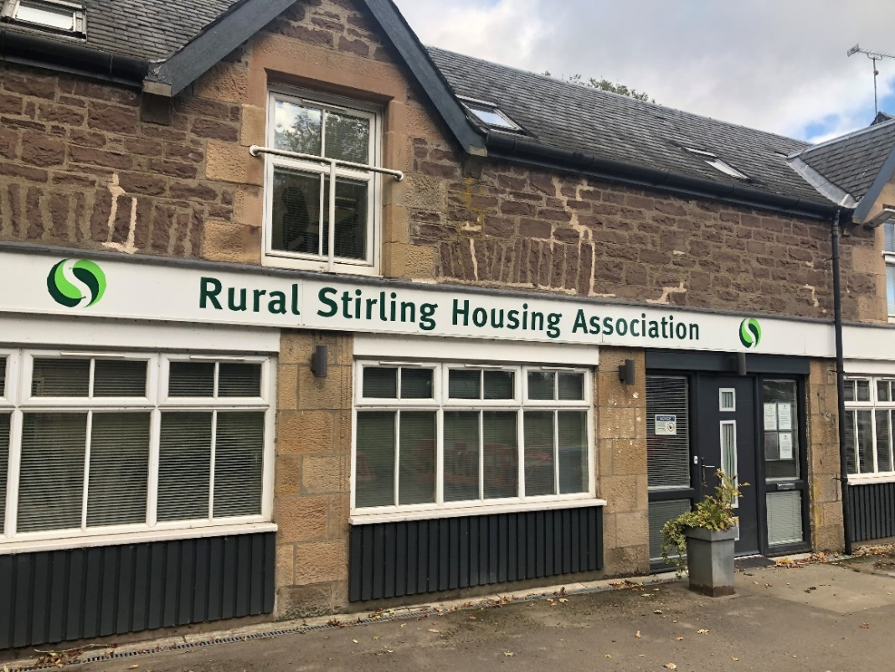




Registered as a Scottish Charity No. SC037849
Rural Stirling Housing Association is a registered society under the Co-operative and Community Benefit Societies Act 2014 No. 2376 (s)
Registered with the Scottish Housing Regulator
Property Factors No. PF000330
Letting Agent Registration Number: LARN1907004



Group Role Descriptions for Governing Body Members and Office Bearers

Rural Stirling Housing Association, Stirling Road, Doune, FK16 6AA
Registered as a Scottish Charity No. SC037849
Venachar Limited, Incorporated under the Companies Act (Company Number SC447415), Registered Office: Stirling Road, Doune, FK16 6AA
Policy Name | Group Role Descriptions for Governing Body Members and Office Bearers
Policy Category | Governance
Data Policy Reviewed | 9 October 2025
Review Period | 3 Years
Next Review Due | October 2028
Equality Impact Assessment | N/A

Background

The role descriptions in this document have been adapted from the Scottish Federation of Housing Associations (SFHA) Model Role Descriptions for Governing Body Members and Office Bearers 2024. The content is also consistent with the SFHA Model Rules 2020, adopted by the Association in October 2020.
Role descriptions are provided for;
- Governing Body Members
- Chair
- Vice Chair
The Rural Stirling Group (RSG) has assigned the role of the Secretary to the CEO. This is reflected in the Standing Orders and Schedule of Delegation and a separate Role Description is not necessary.
Role Description Governing Body Member of Rural Stirling Group (GBM)
“The Governing Body leads and directs the RSL to achieve good outcomes for its tenants and other service users.” Regulatory Standards of Governance and Financial Management, Standard 1

1.1 This role description has been prepared to set out the responsibilities that are associated with being a Governing Body Member (GBM) of Rural Stirling Group (RSG). The role description also applies to GBMs of Venachar Ltd. a wholly owned subsidiary within the RSG. The role descriptions should be read in conjunction with the Rules and Standing Orders and the RSG Governing Body Members Guide.
1.2 RSHA is a Registered Social Landlord and a Scottish Charity. The GBM role description reflects the principles of good governance and takes account of (and is compliant with) the expectations of the SHR Regulatory Standards of Governance and Financial Management for Scottish RSLs and relevant guidance produced by the Office of the Scottish Charity Regulator (OSCR).
1.3 We encourage people who are interested in our work to consider seeking election as a GBM and we are committed to ensuring broad representation from the communities that we serve.
Our GBMs do not require ‘qualifications’ but, from time to time, we will seek to recruit people with specific skills and experience to add to or expand the existing range of skills and experience available to ensure that the governing body is able to fulfil its purpose. We have developed a profile which describes the skills, qualities and experience that we consider we need to lead and direct our organisation and we carry out an annual review of the skills that we have and those that we need to inform our recruitment activities.
1.4 This role description applies to all members of the governing body, whether elected or co-opted or appointed, new or experienced. It is subject to periodic review.
2.0 Primary Responsibilities
2.1 As a GBM your primary responsibilities are, with the other members of the governing body, to
- Lead and direct our work
- Promote and uphold our values
- Set and monitor standards for service delivery and performance
- Control our affairs and ensure compliance
- Uphold our Code of Conduct and promote good governance
2.2 Responsibility for the operational implementation of strategies and policies is delegated to the CEO.
3.0 Key Expectations
3.1 RSG has adopted a Code of Conduct for GBMs which every member is required to sign on an annual basis and uphold throughout their membership of the governing body.
3.2 Each GBM must accept and share collective responsibility for the decisions properly taken by the governing body. Each GBM is expected to contribute actively and constructively to our work. All members are equally responsible in law for the decisions made.
3.3 Each member must always act only in the best interests of RSG and of our customers, and not on behalf of any interest group, constituency or other organisation. GBMs cannot act in a personal capacity to benefit themselves or someone they know.
3.4 Our Rules contain specific requirements that all GBMs should be aware of, including
- The governing body must have at least seven members
- The quorum for a meeting of the governing body is four members, who must be elected or have filled a casual vacancy
- The quorum for a sub-committee meeting is three members, who must be elected or have filled a casual vacancy
- Co-opted members cannot make up more than one third of the governing body; they do not contribute to a quorum being achieved and cannot be elected to an Office Bearing role
- The Secretary must present a report to the last governing body meeting before the AGM confirming that all the requirements of Rule 62-67 have been met
- An experienced GBM (who has nine or more years’ experience with the RSL) must have the agreement of the governing body if they intend to seek re-election for a further term: the governing body’s agreement should be recorded in the relevant minute
- A GBM ceases to be a member of the governing body if they miss four consecutive meetings without, first, having been granted leave of absence
- A GBM who has declared an interest in a matter to be discussed at a meeting may be asked to leave the meeting before the natter is discussed, and cannot vote on the issue
4.0 Main Tasks
- To contribute to formulating and regularly reviewing our values, strategic aims, business objectives and performance standards
- To monitor our performance
- To be informed about and ensure our plans take account of the views of tenants and other customers
- To ensure that we operate within and be assured that we are compliant with the relevant legal requirements and regulatory frameworks
- To ensure that risks are realistically assessed and appropriately monitored and managed
- To ensure that we are adequately resourced to achieve our objectives and meet our obligations
- To oversee and ensure our financial viability and business sustainability whilst maintaining rents at levels that are affordable to tenants
- To act, along with the other members of the governing body, as the employer of our staff
- To ensure that we are open and accountable to tenants, regulators, funders and partners

5.0. Duties
- Act at all times in the best interests of RSG
- Accept collective responsibility for decisions, policies and strategies
- Attend and be well prepared for meetings of the governing body and sub-committees
- Contribute effectively to discussions and decision making
- Exercise objectivity, care and attention in fulfilling your role
- Take part in ongoing training and other learning opportunities
- Take part in an annual review of the effectiveness of our governance and of your individual contribution to our governance
- Maintain and develop your personal knowledge of relevant issues and the wider housing sector
- Represent us positively and effectively at all times, including in our local communities and when attending meetings and other events
- Respect and maintain confidentiality of information
- Treat colleagues with respect and foster effective working relationships within the governing body and between the governing body and our staff
- Be aware of and comply with our policy on the restrictions on payments and benefits
- Register any relevant interests as soon as they arise and comply with our policy on managing conflicts of interest
6.0 Commitment
An estimate of the annual time commitment that is expected from our GBMs is:
Activity | Time (hours)
Attendance at up to 8 regular meetings of the governing body | 16
Reading and preparation for meetings of the governing body | 16
Attendance at sub-committee meetings (optional) | 6
Reading and preparation for sub-committee meetings (optional) | 6
Attendance at annual planning and review events (including individual review meeting) | 6
Attendance at events such as estate tours, tenant / customer conferences, openings and site visits | 4
Attendance at mandatory internal briefings and training events, including Annual Health & Safety Awareness and Annual Governance briefings. | 8
Attendance at optional training events | 8
External Training and conference attendance (may include overnight stay or weekend) | 4
Total | 74

7.0 What RSG Offers GBMs
7.1 All of our GBMs are volunteers and receive no payment for their contribution. We have adopted an Entitlements, Payments and Benefits Policy which prevents you or someone close to you from inappropriately benefiting personally from your involvement with us. This and related policies also seek to ensure that you are not unfairly disadvantaged by your involvement with us. All out of pocket expenses associated with your role as a GBM will be fully met and promptly reimbursed.
7.2 In return for your commitment, we offer:
- A welcome and introduction when you first join the governing body;
- Formal induction training to assist settling in
- A mentor from the governing body if required
- Clear guidance, information and advice on your responsibilities and on our work
- Papers which are clearly written and presented, and circulated in advance of meetings through our online portal oneAdvanced
- The opportunity to put your experience, skills and knowledge to constructive use
- The opportunity to develop your own knowledge, experience and personal skills
- The chance to network with others with shared commitment and ideals

8. Annual Review
8.1 Each GBM will be expected to participate in an annual review of the effectiveness of your contribution to our governance.

Role Description for Chair of Rural Stirling Group
1.0 Introduction
1.1 This role description sets out the particular duties and responsibilities of the Chair of RSHA, the Chair of RSHA’s Audit and Risk Sub-committee and the Chair of Venachar. The responsibilities described here are additional to those set out in the governing body members’ (GBM) role description. It should be considered alongside our Rules, Standing Orders, Code of Conduct and Entitlements, Payments and Benefits Policy and the RSG Governing Body Members Guide.
1.2 This role description will be used to support the annual review of the governing body’s effectiveness. It will be used to appoint the Chairs of RSHA and Venachar and the RSHA Sub-committee Chair after each AGM. GBMs who wish to be considered for this office will be invited to say how, if elected, they will carry out the duties that are set out here before the election takes place.
1.3 In the event that the Chair is unable to fulfil their responsibilities, the Vice Chair will carry out the duties of the Chair.
1.4 As set out in the Standing Orders, the Chair of RSHA may not also serve as the Chair of the Sub-committee. The Sub-committee must elect a different Chair.
An overview of the Role of the Chair is outlined in Rule 59.6 of our Rules.
1.5 The Chair will be elected by the governing body each year at the first governing body meeting following the AGM. Whilst the Chair of RSHA can be re-elected, in accordance with Rule 59.11 of our Rules, they cannot serve a continuous term of more than five years. There is no expectation that the Chair must serve the full five-year maximum term.
1.6 In the spirit of our rules, if an individual has served five years as Chair, they should not be subsequently re-elected as Chair at any point.
2.0 Key Responsibilities
2.1 The Chair must act, and be seen to act, at all times on behalf of the governing body.
The Chair’s key responsibilities are:
- To lead the governing body or Sub-committee constructively, provide direction and manage meetings effectively
- To develop and maintain a constructive and positive working relationship between the Chair, CEO and senior staff
- To uphold our Code of Conduct and promote good governance
- Ensure decision making complies with Standing Orders and Schedule of Delegation
- To be a positive and effective ambassador of RSG
- To ensure that our business is conducted effectively between meetings and that emergency decisions are taken appropriately when required and reported to the governing body
- To be accountable for the actions of the Chair
3.0 Leadership and Direction
3.1 The Chair is expected to:
- Lead by positive action and example
- Represent us positively and effectively
- Set the style and tone of governing body or Sub-committee meetings to ensure effective and participative decision making
- Promote and uphold the Code of Conduct for our governing body
- Ensure that the necessary arrangements are in place to enable us to honour our obligations, achieve our objectives and meet agreed targets
- Demonstrate and support the principles of good governance at all times
- Ensure that the governing body has access to the range of skills, knowledge and experience necessary for the achievement of our aims and objectives and for the fulfilment of the governing body’s responsibilities
- Ensure that the governing body has access to the necessary advice, information and support to fulfil its responsibilities and that, where appropriate, external and/or specialist advice is sought
- Provide support to new and experienced governing body members by promoting access to relevant induction, training and development opportunities
- Establish a constructive relationship with other Office Bearers
- In the event that it is necessary, be responsible for the implementation of the Protocol that provides for investigations into an allegation that a GBM may have breached the Code of Conduct
4.0 Working with the CEO
4.1 The Chair should:
- Establish a constructive relationship with the CEO and ensure that their respective roles of leading and managing are recognised and promoted effectively. The Sub-committee Chair should establish similar relationships with the CEO and other relevant senior staff members.
- Ensure that the conduct of our business continues effectively between meetings of the governing body and act under delegated or emergency authority when necessary.
- In the event of a vacancy, ensure that effective arrangements are implemented for the recruitment and appointment of a CEO, in accordance with our agreed recruitment practices.
- Meet regularly with the CEO and other Office Bearers to consider Board meeting agendas and act as a sounding Board between meetings.
- Meet regularly with the CEO on a one to one basis to provide support.
- Carry out, with at least one other governing body member, the CEO’s annual People Development and Review (including setting objectives, overseeing performance and requiring professional development) and report to the governing body.
- Ensure that appropriate arrangements are in place and implemented effectively for the support and remuneration of the CEO.
- In the event that it is necessary, be responsible for dealing with a grievance or disciplinary action in respect of the CEO, in accordance with our agreed procedures.
5.0 Promoting Good Governance
5.1 The Chair is required to:
- Promote and demonstrate the highest standards of ethical conduct and integrity
- Build and sustain constructive relationships with other Office Bearers, members of the governing body and senior staff
- Initiate any investigation under the terms of our Code of Conduct
- Chair all general meetings in accordance with the Rules
- Chair all governing body meetings, in accordance with the Rules and Standing Orders
- Ensure that all governing body members have access to appropriate information (including specialist, independent and/or professional advice) and have an opportunity to contribute to discussion and consideration of all matters requiring their attention
- Ensure that effective induction and ongoing training and support is provided to all governing body members and that annual performance reviews are conducted in accordance with our policy
- Manage meetings inclusively and effectively to ensure that there is sufficient time for the consideration of all relevant issues; for performance to be monitored effectively and for risk to be assessed realistically
- Ensure that all delegated authorities are monitored and reporting arrangements are implemented effectively
6.0 Conduct of Business
The Chair is expected to:
- Ensure that business is efficiently and accountably conducted between governing body meetings.
- Sign (or otherwise authorise) payment instructions and documents requiring the governing body or the Chair’s authorisation, in accordance with our Standing Orders.
- Take decisions on behalf of the organisation in the event of emergencies that occur outside the regular meeting cycle and report these back to the governing body for ratification.
- Ensure that the range of skills, knowledge and experience required to lead the RSG effectively is available to the governing body and that the governing body is able to access specialist support when necessary.
- Lead the governing body’s Succession Planning and recruitment to ensure good governance and regulatory compliance.

Role Description for Vice Chair(s) of Rural Stirling Group

- Introduction

  - This role description sets out the particular duties and responsibilities that attach to the Vice Chair(s). The responsibilities described here are additional to those set out in the governing body members’ (GBM) role description. It should also be considered alongside
- the Role Description for the Chair,
- our Rules
- Standing Orders; and
- RSG Governing Body Members Guide.
1.2 In the event that the Chair is unable to fulfil their responsibilities, the Vice Chair will carry out these duties.
1.3 The position of Vice Chair will be elected by the governing body, every year at the first meeting following the AGM.
In accordance with Rule 59.11 of RSHA’s Rules, the Chair cannot serve a continuous term of more than five years. There is no expectation that the Chair must serve the full five-year maximum term.
1.4 There is no fixed term of office for the vice-chair, although they cannot serve for more than five years continuously. RSG encourages the rotation of the vice-chair’s office as part of its approach to effective succession planning, in order to provide opportunities for GBMs to develop their skills and experience.
1.5 When the Chair stands down, the Vice Chair(s) in post will be asked if they wish to stand for election to become Chair; other members of the governing body are also able to stand for election as Chair at the same time.
1.6 The role of Vice Chair must be carried out by a governing body member and may also be carried out by a former Office Bearer.
2. Role of Vice Chair
2.1 The role of the Vice Chair(s) is to deputise, support and (where required) stand in for the Chair.
2.2 When known in advance, the Vice Chair should ensure that they are available for any governing body meeting that the Chair is unable to attend – e.g. where the Chair has booked a holiday. Close liaison with the Chair is a key requirement of the role.
2.3 The individual(s) holding the post of Vice Chair will gain training and insight as to whether they would like to consider performing the role of Chair in the future. To aid succession planning and as and when required, the post of Vice Chair may be held jointly between members of the governing body.
Review
These Role descriptions were approved by the governing body on 9 October 2025 It will be reviewed by the governing body every 3 years from adoption.

Application for Membership of Rural Stirling Housing Association
Rural Stirling Housing Association is a Registered Social Landlord. We are a registered society under the Co-operative and Community Benefit Societies Act 2014 and a Scottish Charity. Membership is open to people who are interested in supporting our activities – our membership policy explains who can apply.
If you would like to apply to become a Member, please complete this form and send it to sandra@rsha.org.uk or by post to Rural Stirling Housing Association, Stirling Road, Doune, Perthshire, FK16, 6AA
You must enclose £1 with your application which will purchase your ‘share’ if your application is successful (it will be returned if not).

Full Name (including middle names)

Address

Postcode

Are you over 16?

Email Address

Contact Telephone Number
- Are you a tenant or resident of Rural Stirling Housing Association? |  |  | YES / NO
- Are you related to an employee or member of the Board of Management of Rural Stirling housing Association? |  |  | YES / NO
If yes, please say who
- Are you a member of any other Housing Association or Co-operative? |  |  | YES / NO
If Yes, please provide further details
Please advise why you want to become a member Rural Stirling Housing Association and which aspect of our work you are especially interested in.
Would you be interest in joining our Board of Management |  | YES / NO

I,(print Name) __________________________________________ wish to become a member of Rural Stirling Housing Association and I enclose £1 as payment for one share.

Signed __________________________________________

Date ___________________________________________

Membership applications are presented to our Board of Management for approval. If you application is approved you will be issued with a Share Certificate shortly after the approval meeting.

For internal Use
Application Received __________________________________________________
£1 payment received __________________________________________________
Presented to Board of Management ______________________________________
Membership Approved: YES / NO

Eligibility Declaration
Please confirm your eligibility to be considered as a prospective member of Rural Stirling Housing Association’s Board of Management by ticking the “I Agree” box; if you are unable to confirm any of the statements, please provide details:
 | I Agree | Comments/Details
You are not an undischarged bankrupt

You have not entered into an arrangement with your creditors
You have not been convicted of a crime of dishonesty for which the statutory rehabilitation period has not expired
You have not been convicted of an offence under the Charities and Trustee Investment (Scotland) Act 2005
You are not party to any legal proceedings in any Court of Law by or against Rural Stirling Housing Association or Venachar
You have not been removed from the governing body of another RSL within the last five years
You have not resigned from the Governing Body at any time during the last five years after receiving notice that a special committee meeting was to be held to consider your removal
You have not been removed from the Governing Body during the last five years
You have not been removed or suspended from a position of management or control of a charity under the provisions of the Law Reform (Miscellaneous Provisions) (Scotland) Act 1990 of the Charities and Trustee Investment (Scotland) Act 2005
You have not been removed from the office of Charity Trustee or trustee for a charity by the Charity Commissioners in England or Wales or by the High Court of Justice
You are not the subject of a Disqualification Order or have had a disqualification undertaking made against you
You are not related to a member of the Governing Body of RSHA or Venachar

Name and Signature of member being nominated

Name (print name) ________________________________________________
Signature ________________________________________________
Date ________________________________________________

Board Member Application Form
This form should be completed by any person seeking to join the Board of Management of Rural Stirling Housing Association. When completing the form, please refer to information about the skills and knowledge that RSHA is particularly looking for at this time.

Where the applicant is being nominated for election, this form should be completed in addition to the Nomination Form. Information marked with an asterisk (*) will be included with the ballot papers issued to members.

Full Name (including middle name(s)) *
Full Address

Telephone No: | Email Address

i. | Are you a tenant of Rural Stirling Housing Association | YES / NO
ii. | Are you an owner who receives a factoring service from Rural Stirling Housing Association | YES / NO
iii. | Are you related to anyone who is already a member of Rural Stirling Housing Association’s Board of Management or to someone who is employed by Rural Stirling Housing Association? | YES / NO
If you answered YES to (iii), please give name of the Board or Staff member
_________________________________________________________________________________
iv. | Are you involved with any business that provides services or is a contractor to Rural Stirling Housing Association? | YES / NO
If you answered YES to (iv), please provide details
_________________________________________________________________________________
v. | Are you employed? | YES / NO
If you answered YES to (iv), please provide details
_________________________________________________________________________________
________________________________________________________________________________
v. | Are you (or have you been) involved in other voluntary work? | YES / NO
If you answered YES to (iv), please provide details
_________________________________________________________________________________
_________________________________________________________________________________
*Please describe why are you interested in joining Rural Stirling Housing Association’s Board of Management.

*Please describe how your experience would help meet the recruitment priorities that Rural Stirling Housing Association has identified (priorities are provided within the information attached)
*We are committed to promoting equality and human rights, valuing diversity, and challenging prejudice and discrimination in all its forms. What does this mean to you and why is this important to Rural Stirling Housing Association?

*Please describe which part of Rural Stirling Housing Association’s work you are especially interested in and why.

vi. | Are you willing and able to participate in training on a regular basis? | YES / NO

I confirm that I have read the Board Member’s Profile and Eligibility Form and that I am eligible and willing to stand for election.
Signature
Date

Scottish Housing Regulator (February 2024) Regulatory Framework

