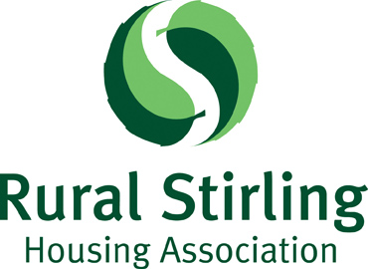

Board Member Application Form

This form should be completed by any person seeking to join the Board of Management of Rural Stirling Housing Association. When completing the form, please refer to information about the skills and knowledge that RSHA is particularly looking for at this time.

Where the applicant is being nominated for election, this form should be completed in addition to the Nomination Form. Information marked with an asterisk (*) will be included with the ballot papers issued to members.

*Name: _____________________________________________________

*Address: _____________________________________________________

______________________________________________________

Postcode: _______________ Telephone: __________________

Email: _________________________________________

*Are you a tenant of RSHA? Yes / No

Are you an owner who receives a factoring service from RSHA? Yes / No

Are you related to anyone who is already a member of RSHA’s Board of Management or to someone who is employed by RSHA? Yes / No

(If ‘yes’ please give your relative’s name) _____________________________

Are you involved with any business that provides services or is contracted to RSHA? Yes / No

(If ‘yes’, please give details): ___________________________________________

Are you employed? Yes/No

(If ‘yes’, please give details): ___________________________________________

Are you (or have you been) involved in other voluntary work? Yes/No

(If ‘yes’ please provide details): ________________________________________

_________________________________________________________________
Continued overleaf/…

*Please describe why you are interested in joining RSHA’s Board of Management:

____________________________________________________________________________________________________________________________________________________________________________________________________________________________________________________________________________

*Please describe how your experience would help to meet the recruitment priorities that RSHA has identified in 2022 (the priorities are enclosed with this form):

__________________________________________________________________________________________________________________________________________________________________________________________________________________________________________________________________________________________________________________________________________________________________________________________________________________

*Please describe which part of RSHA’s work are you especially interested in and why:

______________________________________________________________________________________________________________________________________________________________________________________________________

Are you willing and able to participate in training on a regular basis? Yes / No

I confirm that I have read the Board Member’s Profile and Eligibility Form and that I am eligible and willing to stand for election.

Signature: ___________________________________________

Date: ____________

